1. Task Activity Status
- Added filtering logic for the website
- Added functionality to support adding new shelter locations with their relevant attribute data
- Made dummy shelter for testing attributes

2. Interactions and Task Procedures
To avoid overcomplicating the system, we chose not to use a database. Instead, we treated our local geosjson folder as a lightweight database. When a user adds a new shelter through the interface, the shelter’s attributes (square footage, accessibility, and proximity features) are captured in the form and saved to the shelter geojson file in the data folder. This keeps the data readable and modifiable with simple Python scripts and avoids the need for database setup and maintenance. This allows us to immediately visualize new shelters on the map and use them in filter logic. To test this, we added a few dummy shelters with varying attributes to ensure that filtering and display logic worked as expected. We’re still working on the functionality that allows users to delete existing shelters from the map and data folder.
We introduced several filters in the sidebar that allow users to select shelters based on attribute thresholds like square footage or proximity to transit. This was done in JavaScript using checkboxes, sliders, and event listeners that trigger the map layer to re-renders with the matching features shown without page reloads.
3. Information products
Website with filters toggled off:
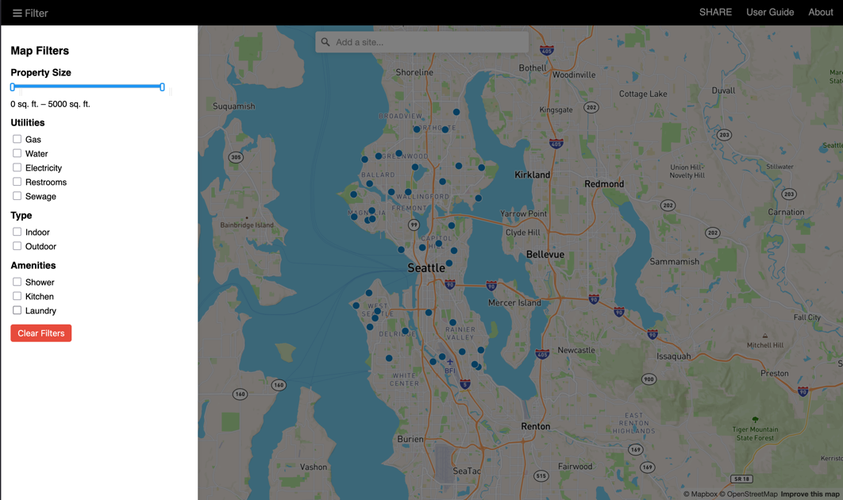
Map with a few filters toggled on:
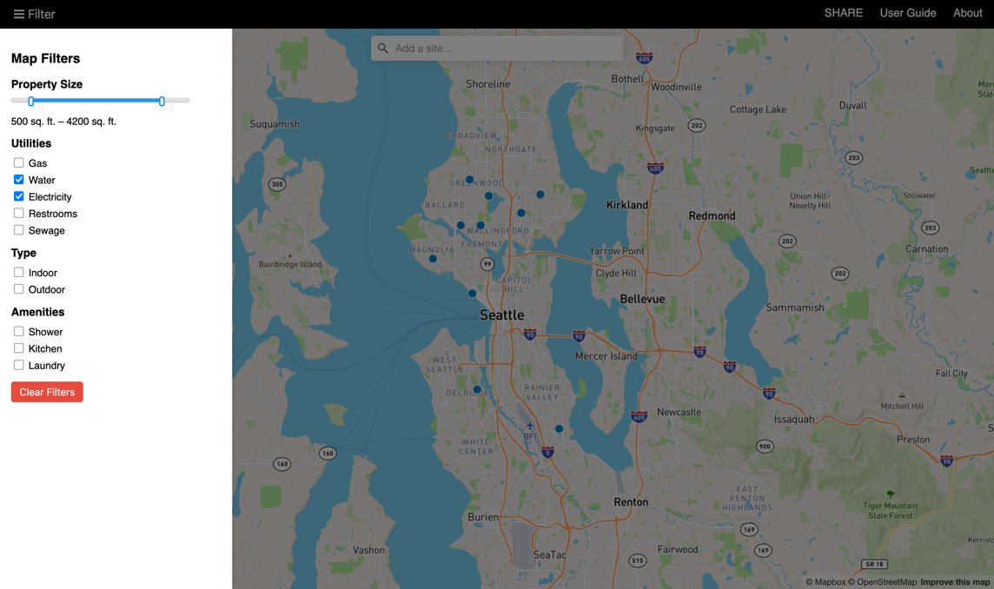

4. Reflect on Major Accomplishments in the Prior Two Weeks
A significant realization was that we didn’t need a full backend database to manage dynamic data, using geojson as a lightweight database. This allowed us to focus more on the front end experience. I also became more comfortable integrating Python and JavaScript. Writing dummy shelters helped debug and visual styling for the website. Through the UI filtering work, I realized how important real time feedback is when designing spatial interfaces . The quick toggling and instant updates make the site feel more alive, hopefully making the website easier to use on the field. Overall, it was nice to see our website slowly coming together.

